**Assignment 1 for Module 1**

**Report for Crowdfunding Campaign**

The crowdfunding campaigns had a higher overall success rate throughout the year. June and July were the most favorable months for successful campaigns, as shown in Figure 1, with the highest reported numbers. August was a relatively unfavorable month for successful campaigns, with a corresponding spike in failed campaigns. The number of canceled campaigns was relatively low throughout the year, especially from April to July, with a slight uptick at the end of the year.

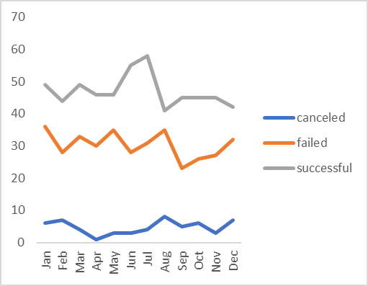

Figure1. Graph depicting the progress of the crowdfunding campaigns through the year.

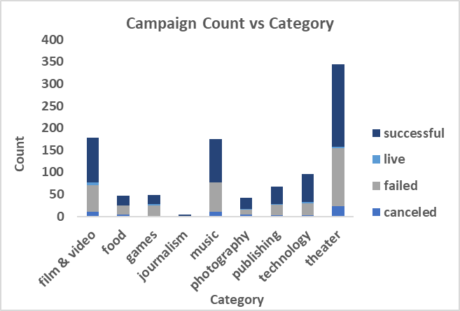

Figure 2. Graph showing the breakdown of campaign count for each category where the campaign count is further divided by the number of successful, live, failed, and canceled campaigns.

Another conclusion can be drawn from the campaign count for each category broken down by the number of successful and unsuccessful campaigns. Theater is the primary category with the highest number of campaigns overall, and journalism had the lowest number of reported campaigns.

The dataset is very skewed regarding the number of campaigns for different categories. Theater, film, and music comprise the bulk of the dataset for the campaign count. Gauging the overall success of the campaigns, like in Figure 1, will be heavily influenced by three categories.

To better understand the trends in crowdfunding campaigns, making a separate table with campaign counts for each category filtered by year might give us a better sense of how the campaigns are faring for individual categories throughout the year. Another way to organize the data might be to create a table and graph showing the campaign count divided by country to understand the trend better.

**Statistical Analysis**

In this case, the Mean is a better indicator than the median because the median value is far off from the mean. The standard deviation of the dataset from the mean of 851 is 1267 for successful campaigns and 1178 from 586 for failed campaigns. Since the data has high variability, the mean will be a better indicator for both campaigns.